- Program ID : VH002MA1

- Display Layout
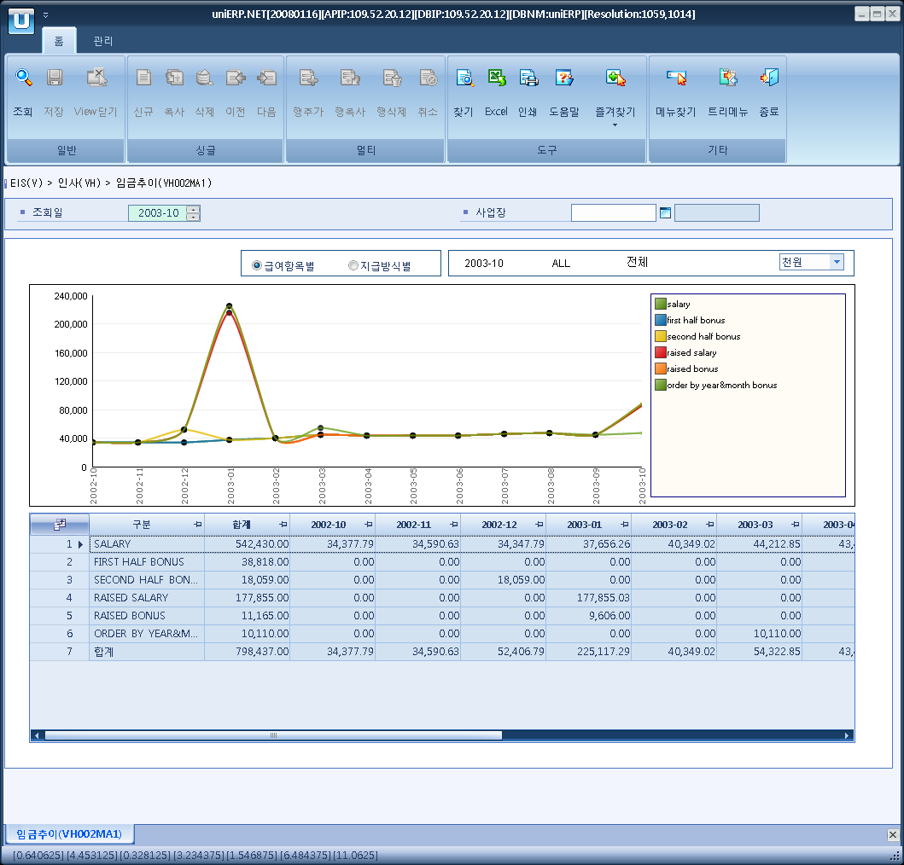

- Event flow
- Click Query button
- OnFncQuery -> DbQuery -> DataChange
- Display Unit combo change
- uniCombo1_ValueChanged -> DataChange

- SQL Statements
- Pay type
SELECT a.prov_type, b.minor_nm,
ISNULL(SUM(ISNULL(a.pay_tot_amt, 0) + ISNULL(a.bonus_tot_amt, 0)), 0) AS total,
ISNULL(SUM(CASE a.pay_yymm WHEN CONVERT(CHAR(6),DATEADD(MONTH, -12, @stryyyymm+'01'), 112) THEN ISNULL(a.pay_tot_amt, 0) + ISNULL(a.bonus_tot_amt, 0) END), 0) AS m12,
ISNULL(SUM(CASE a.pay_yymm WHEN CONVERT(CHAR(6),DATEADD(MONTH, -11, @stryyyymm+'01'), 112) THEN ISNULL(a.pay_tot_amt, 0) + ISNULL(a.bonus_tot_amt, 0) END), 0) AS m11,
ISNULL(SUM(CASE a.pay_yymm WHEN CONVERT(CHAR(6),DATEADD(MONTH, -10, @stryyyymm+'01'), 112) THEN ISNULL(a.pay_tot_amt, 0) + ISNULL(a.bonus_tot_amt, 0) END), 0) AS m10,
ISNULL(SUM(CASE a.pay_yymm WHEN CONVERT(CHAR(6),DATEADD(MONTH, -9, @stryyyymm+'01'), 112) THEN ISNULL(a.pay_tot_amt, 0) + ISNULL(a.bonus_tot_amt, 0) END), 0) AS m09,
ISNULL(SUM(CASE a.pay_yymm WHEN CONVERT(CHAR(6),DATEADD(MONTH, -8, @stryyyymm+'01'), 112) THEN ISNULL(a.pay_tot_amt, 0) + ISNULL(a.bonus_tot_amt, 0) END), 0) AS m08,
ISNULL(SUM(CASE a.pay_yymm WHEN CONVERT(CHAR(6),DATEADD(MONTH, -7, @stryyyymm+'01'), 112) THEN ISNULL(a.pay_tot_amt, 0) + ISNULL(a.bonus_tot_amt, 0) END), 0) AS m07,
ISNULL(SUM(CASE a.pay_yymm WHEN CONVERT(CHAR(6),DATEADD(MONTH, -6, @stryyyymm+'01'), 112) THEN ISNULL(a.pay_tot_amt, 0) + ISNULL(a.bonus_tot_amt, 0) END), 0) AS m06,
ISNULL(SUM(CASE a.pay_yymm WHEN CONVERT(CHAR(6),DATEADD(MONTH, -5, @stryyyymm+'01'), 112) THEN ISNULL(a.pay_tot_amt, 0) + ISNULL(a.bonus_tot_amt, 0) END), 0) AS m05,
ISNULL(SUM(CASE a.pay_yymm WHEN CONVERT(CHAR(6),DATEADD(MONTH, -4, @stryyyymm+'01'), 112) THEN ISNULL(a.pay_tot_amt, 0) + ISNULL(a.bonus_tot_amt, 0) END), 0) AS m04,
ISNULL(SUM(CASE a.pay_yymm WHEN CONVERT(CHAR(6),DATEADD(MONTH, -3, @stryyyymm+'01'), 112) THEN ISNULL(a.pay_tot_amt, 0) + ISNULL(a.bonus_tot_amt, 0) END), 0) AS m03,
ISNULL(SUM(CASE a.pay_yymm WHEN CONVERT(CHAR(6),DATEADD(MONTH, -2, @stryyyymm+'01'), 112) THEN ISNULL(a.pay_tot_amt, 0) + ISNULL(a.bonus_tot_amt, 0) END), 0) AS m02,
ISNULL(SUM(CASE a.pay_yymm WHEN CONVERT(CHAR(6),DATEADD(MONTH, -1, @stryyyymm+'01'), 112) THEN ISNULL(a.pay_tot_amt, 0) + ISNULL(a.bonus_tot_amt, 0) END), 0) AS m01,
ISNULL(SUM(CASE a.pay_yymm WHEN @stryyyymm THEN ISNULL(a.pay_tot_amt, 0) + ISNULL(a.bonus_tot_amt, 0) END), 0) AS m00
FROM hdf070t a, b_minor b
WHERE a.pay_yymm BETWEEN CONVERT(CHAR(6),DATEADD(YEAR, -1, @stryyyymm+'01'), 112)
AND @stryyyymm
AND a.dept_cd IN (SELECT a.dept_cd
FROM b_acct_dept a, b_cost_center b
WHERE a.org_change_dt = (SELECT MAX(org_change_dt)
FROM b_acct_dept
WHERE org_change_dt <= @stryyyymm + '01')
AND a.cost_cd = b.cost_cd
AND b.biz_area_cd LIKE @strBizAreaCd)
AND b.major_cd = 'H0040'
AND b.minor_cd = a.PROV_TYPE
GROUP BY a.prov_type, b.minor_nm
ORDER BY a.prov_type

- Pay method
SELECT a.pay_cd, b.minor_nm,
ISNULL(SUM(a.prov_tot_amt), 0) AS total,
ISNULL(SUM(CASE a.pay_yymm WHEN CONVERT(CHAR(6),DATEADD(MONTH, -12, @stryyyymm+'01'), 112) THEN a.prov_tot_amt END), 0) AS m12,
ISNULL(SUM(CASE a.pay_yymm WHEN CONVERT(CHAR(6),DATEADD(MONTH, -11, @stryyyymm+'01'), 112) THEN a.prov_tot_amt END), 0) AS m11,
ISNULL(SUM(CASE a.pay_yymm WHEN CONVERT(CHAR(6),DATEADD(MONTH, -10, @stryyyymm+'01'), 112) THEN a.prov_tot_amt END), 0) AS m10,
ISNULL(SUM(CASE a.pay_yymm WHEN CONVERT(CHAR(6),DATEADD(MONTH, -9, @stryyyymm+'01'), 112) THEN a.prov_tot_amt END), 0) AS m09,
ISNULL(SUM(CASE a.pay_yymm WHEN CONVERT(CHAR(6),DATEADD(MONTH, -8, @stryyyymm+'01'), 112) THEN a.prov_tot_amt END), 0) AS m08,
ISNULL(SUM(CASE a.pay_yymm WHEN CONVERT(CHAR(6),DATEADD(MONTH, -7, @stryyyymm+'01'), 112) THEN a.prov_tot_amt END), 0) AS m07,
ISNULL(SUM(CASE a.pay_yymm WHEN CONVERT(CHAR(6),DATEADD(MONTH, -6, @stryyyymm+'01'), 112) THEN a.prov_tot_amt END), 0) AS m06,
ISNULL(SUM(CASE a.pay_yymm WHEN CONVERT(CHAR(6),DATEADD(MONTH, -5, @stryyyymm+'01'), 112) THEN a.prov_tot_amt END), 0) AS m05,
ISNULL(SUM(CASE a.pay_yymm WHEN CONVERT(CHAR(6),DATEADD(MONTH, -4, @stryyyymm+'01'), 112) THEN a.prov_tot_amt END), 0) AS m04,
ISNULL(SUM(CASE a.pay_yymm WHEN CONVERT(CHAR(6),DATEADD(MONTH, -3, @stryyyymm+'01'), 112) THEN a.prov_tot_amt END), 0) AS m03,
ISNULL(SUM(CASE a.pay_yymm WHEN CONVERT(CHAR(6),DATEADD(MONTH, -2, @stryyyymm+'01'), 112) THEN a.prov_tot_amt END), 0) AS m02,
ISNULL(SUM(CASE a.pay_yymm WHEN CONVERT(CHAR(6),DATEADD(MONTH, -1, @stryyyymm+'01'), 112) THEN a.prov_tot_amt END), 0) AS m01,
ISNULL(SUM(CASE a.pay_yymm WHEN @stryyyymm THEN a.prov_tot_amt END), 0) AS m00
FROM hdf070t a, b_minor b
WHERE a.pay_yymm BETWEEN CONVERT(CHAR(6),DATEADD(YEAR, -1, @stryyyymm+'01'), 112)
AND @stryyyymm
AND a.dept_cd IN (SELECT a.dept_cd
FROM b_acct_dept a, b_cost_center b
WHERE a.org_change_dt = (SELECT MAX(org_change_dt)
FROM b_acct_dept
WHERE org_change_dt <= @stryyyymm + '01')
AND a.cost_cd = b.cost_cd
AND b.biz_area_cd LIKE @strBizAreaCd)
AND b.major_cd = 'H0005'
AND b.minor_cd = a.pay_cd
GROUP BY a.pay_cd, b.minor_nm
ORDER BY a.pay_cd

